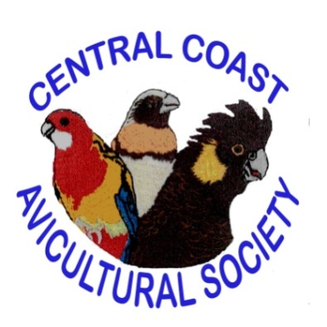
The Avicultural Society of the Central Coast Inc

Meets every Fourth Friday of the Month at 8pm
CLUB WYONG, Anzac Avenue, Wyong
MEMBERSHIP FORM

Full Membership: $25 per year
Family Membership: $30 per year
Junior Membership: Free under 16 yrs

Membership is due on 1st January each year

Name/s……………………..………………..…………………
Address……………………………………..…………………
Post Code………….....…Phone…………..…………………
Email…………………………………….………………………
Post to: The Avicultural Society of the Central Coast Inc
PO Box 4116, LAKEHAVEN NSW 2263

Payments can be made at monthly meeting or by EFT to:

Acct Name: Avicultural Society of the Central Coast Fee Saver
BSB: 082574
Acct No: 170770331

Office use only:
Receipt Number: …………………..………Date Paid: ………………
PLEASE USE FORM WHEN MAKING PAYMENT

